Biological Sciences



Year 9

Body Systems Test

Student Name: ________________________

Date: ________________

Weighting: __8__% total

I acknowledge that all the information contained in this task is my own work and not taken from other sources. If other sources have been used they have been acknowledged in my references.

Marks:

/ 45

___________________________________

(Student Signature)

1. In order to stay healthy, the body must maintain a **stable internal environment.** What is this process called?

a) Reflexive coordination

b) Multicellularity

c) Homeopathy

d) Homeostasis

2. Which of the following is **NOT** a type of neuron?

a) Sensory

c) Temporal

d) Relay

e) Interneuron

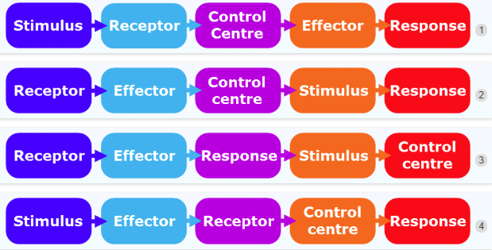3. Which picture correctly shows the order of the stimulus-response model?

a) 1

b) 2

c) 3

d) 4

4. What do nerve cells use to transmit information?

a) Light

b) Electricity

c) Pressure

d) Temperature

5. When an invading pathogen penetrates the tissues, the **inflammatory response** is immediately brought into play.  
State the main purpose of the inflammatory response.

a) To decrease the blood circulation around the infected area.

b) These is no purpose of the inflammatory response.

c) To increase the blood circulation around the infected area.

6. Andrew has tripped on a tree root while running and twisted his ankle. After a few hours he notices that it is **swollen and red**. His ankle has become inflamed.  
Identify which line of defence (immune system) this is.

a) First line of defence

b) Third line of defence

c) Second line of defence

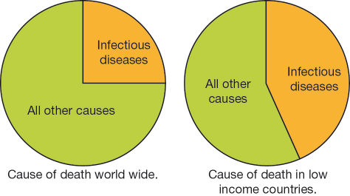7. Calculate the percentage of deaths caused by infectious diseases worldwide and in low-income countries and then identify the correct statement.

a) Infectious diseases cause twice as many deaths in low-income countries compared to the rest of the world.

b) Less than a quarter of the deaths worldwide are caused by infectious diseases.

c) 45% of deaths in low-income countries are caused by infectious diseases.

d) 85% of deaths in the world have a cause other than an infectious disease.

8. An antibody is:

a) a drug produced to treat bacterial infections

b) a special chemical produced by the body in response to the presence of a foreign substance

c) a foreign substance that causes the body to produce antigens

d) a type of white blood cell that can destroy some pathogens.

9. Which of the following is a symptom of a disease?

a) bacteria

b) blood test

c) fever

d) epidemic

10. Which type of neurone transmits a signal from the central nervous system to an effector such as a muscle?

a) Sensory

b) Relay

c) Motor

11. Why do we categorise sneezing as the first line of defence?

a) Because it releases lymphocytes to target the antigen.

b) Because it acts physical barrier to external environment.

c) Because it releases phagocytes to consume the antigen.

d) Because it forces you to take a deep breath of air.

12. Which of the following describes correct passage of information when the body detects a change in temperature

a) Motor neurons detect a change in temperature, and relay neurons pass the information to the CNS

b) Sensory receptors detect a change in temperature and sensory neurons pass the information to the CNS

c) Sensory receptors detect a change in temperature and motor neurons pass the information to the CNS

d) Sensory receptors detect a change in temperature and relay neurons pass the information to the CNS

13. In the disease **multiple sclerosis,** the **myelin sheath** surrounding the axons of neurons in central nervous system is **broken down.** One of the symptoms of multiple sclerosis is weakening of the muscles. Which of the following describes the transmission of information along the axon.

a) Information passed down the axon faster which weakens the muscles

b) Information passed down the axon is impaired or slowed which the PNS cannot process information

c) Information passed down the axon is impaired or slow which the CNS cannot process information

d) Information down the axon is increased which the CNS cannot process

14. Diabetes is a disease where the body can no longer produce insulin which is a hormone that allows your body to use sugar (glucose). Select the **two** options that could be used to treat diabetes

a) Surgery

b) Physiotherapy

c) Diet changes

d) Insulin

15. State an advantage of specificity (only killing specific foreign substances) in lymphocytes

a) The lymphocyte can remember the specific pathogen that invaded the body

b) It helps to build up a tolerance against all pathogens

c) It allows lymphocytes to identify the pathogen from the rest of the cells in your body

**Section B- Short Answer (30 marks)**

1. a) Draw a labelled diagram of a neuron below including the terms; **(6 marks)** **axon, myelin sheath, nucleus, dendrite, axon terminal, cell body**

b) Describe the function of the **axon, myelin sheath, axon terminal** and **dendrite (4 marks)**

___________________________________________________________________________________________________________________________________________________________________________________________________________________________________________________________________________________________________________________________________________________________________________________________________________________________________________________________________________________________________________________________________________________________

_______________________________________________________________________________________________________________________________________________________________________________________________________________________________________

2. Explain the difference between sensory, interneurons and motorneurons **(3 marks)**

______________________________________________________________________________________________________________________________________________________________________________________________________________________________________________________________________________________________________________________________________________________________________________________________________________________________________________________________________________

3. What are the different roles of the two white blood cells in protecting our body from infection? (Ensure for each that you state their role, line of defence) **(4 marks)**

a) Phagocytes (consumes or engulfs antigen, 2nd line)

_______________________________________________________________________________________________________________________________________________________________________________________________________________________________________

b) Lymphocytes (creates antibodies or marks for consumption by phagocytes, 3rd line)

_______________________________________________________________________________________________________________________________________________________________________________________________________________________________________

4. State how information is transmitted across neurons **(5 marks)**

______________________________________________________________________________________________________________________________________________________________________________________________________________________________________________________________________________________________________________________________________________________________________________________________________________________________________________________________________________

5. Fred was strolling through a forest and came across a big angry grizzly bear. The bear started to roar loudly and began to chase Fred. This made Fred’s heart rate, blood pressure, and the amount of glucose in his bloodstream all increase.

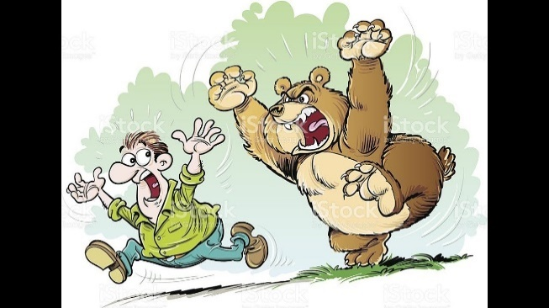

a) What is the name of the response that helped Fred to battle the bear or run away from the danger? **(1 mark)**

_____________________________________________________________________________

b) List **one** hormone which would be released in Fred’s body during this encounter? **(1 mark)**

_____________________________________________________________________________

c) Discuss the series of body responses displayed when Fred sees the bear in the woods. Use the diagram below to help you with your answer. **(6 marks)**

